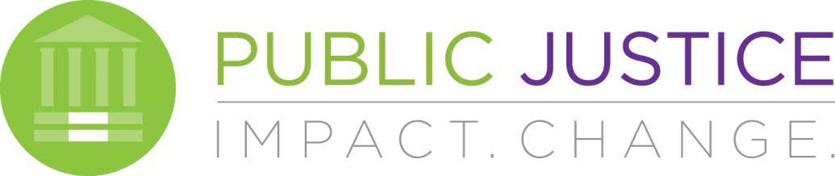

National Headquarters 1620 L Street NW, Suite 630, Washington, DC 20036 West Coast Office 475 14th Street, Suite 610, Oakland, CA 94612

JOB ANNOUNCEMENT

Please post and inform potential applicants.

January 2023
CREATIVE CONTENT COORDINATOR

Public Justice seeks a full-time entry- to mid-level creative content coordinator to take a lead role in growing our organization’s digital presence and reach across all digital channels and functions, with a focus on content creation for social media.

Public Justice takes on the biggest systemic threats to justice of our time – abusive corporate power and predatory practices, the assault on civil rights, and the destruction of the earth’s sustainability. We connect high-impact litigation with strategic communications and the strength of our partnerships to fight these abusive and discriminatory systems and win social and economic justice.

In particular, we ensure access to the civil justice system, protect the civil rights of students, boldly lead efforts to reform the industrial agriculture system, fight to end qualified immunity and modern-day debtor’s prisons, enforce the nation’s most important environmental laws, and much more.

This is a unique opportunity to join a vibrant and thriving non-profit communications shop focused on messaging and marketing some of the most high-profile progressive advocacy issues. Working within a small communications shop, the Creative Content Coordinator will have the opportunity to tackle a diverse array of policy and advocacy projects while elevating Public Justice’s digital footprint through strategic and consistent content creation.

The Creative Content Coordinator is responsible for identifying content gaps and creating and managing all the digital content on the website and social media.

This position is a nonexempt position, is open immediately, is part of the organization’s Department of External Affairs, and reports to the Director of Communications. Candidates can choose to work in the Washington, DC or Oakland, CA office, but also have the option to work remotely from other parts of the country.

Key Responsibilities Include:

Create, schedule, and post high quality, shareable content to Public Justice’s digital channels
- Coordinate social media advertising campaigns (Facebook, Instagram, YouTube), and work with Development Team to maintain unpaid and paid search acquisition/SEO efforts (Google Grant, Microsoft Ad Grants)
- Grow social media following and online presence while maintaining our design and adhering to organizational guidelines
- Attend, record, and live post from in-person and virtual events
- Monitor engagement (DMs and comments) on social channels and respond when appropriate
- Work with Communications and Development team to develop content for attorney and non-attorney audiences and key stakeholders, including members, donors, partners, and organizational allies
- Collaborate with greater staff, co-counsel, grassroots partners, and clients to develop and execute digital content for storytelling campaigns
- Track and report on metrics across digital channels to produce regular digital analytics reports
- Track and stay up to date on the latest development in new mediums, content trends, execution tactics, and changing social media landscapes to ensure audience engagement and online presence
- Assisting the Communications staff with other tasks as needed

Qualifications
We’re looking for a team player with a keen interest in beginning, or expanding, their career in public interest communications. Excellent writing and editing skills are a must.

Preferred background and skills include:

  - Experience in the digital communications field, with an emphasis on social media (Twitter, Facebook, Instagram, TikTok, YouTube)
  - Experience with graphic design and digital media software to produce content, including short videos, audio segments, infographics, and other creative outputs (i.e. Adobe Creative Cloud Suite, Canva)
  - Ability to effectively communicate with general/public audiences about complicated or technical legal/advocacy issues
  - Experience working with progressive advocacy organizations or campaigns and/or legal advocacy groups
  - Familiarity with web content management systems (preferably WordPress) and mass email programs (such as Constant Contact and EveryAction)
  - Familiarity with current online tools and marketing trends, including Sprout Social, SEO, Airtable

Compensation and Benefits
Public Justice offers a mission-focused work environment, a teamwork and community-oriented approach, and a competitive compensation package. We provide excellent benefits, including four-day work weeks, at least three weeks of paid vacation, two weeks of sick leave, two personal days each year, all federal and some local holidays, employer-paid health, dental and vision insurance premiums, and a 401(k) plan.
The salary for this position will be between $52,000 and $60,000, depending on experience. Public Justice requires those working in its offices to be fully vaccinated against COVID-19. Reasonable accommodations to this requirement, including remote work, based on disability or a sincerely held religious belief, will be considered.

How to Apply
Interested candidates should send a resume, cover letter, portfolio, and contact information for two references to lsears@publicjustice.net with the subject line ‘Creative Content Coordinator.’ Applicants are encouraged to submit their materials by February 17, 2023, at which point applications will be reviewed on a rolling basis until the position is filled

Reasonable Accommodations
Public Justice is an equal opportunity employer and values a diverse workplace. We strongly encourage applications from people with disabilities; people of color, including bilingual and bicultural individuals; LGBTQ individuals; people of all genders; veterans; and people of all ages. Public Justice is committed to providing reasonable accommodations to individuals with disabilities. If you require reasonable accommodations during any part of the hiring process, please email lhughes@publicjustice.net.

